Uyen Tang

COSC 412

Towson University



Play It FoRWARD

SPMP INDIVIDUAL PROJECT

1. **Introduction**
   1. Project Overview

* Play It Forward will be a website for a subscription service that provides a monthly mystery box full of toys for dogs and cats. Once the subscribers have tested the products, they have 3 options:
  + Return the “rented” toy to Play It Forward for cleaning and redistributing.
  + Keep the Cat or Dog’s new favorite toy and pay via the Play It Forward Website.
  + Extra option: The subscriber can include an additional toy they already own to exchange for a discount code for 15% off their next Play It Forward Mystery box.
* This idea is inspired by the Rotating Closet Idea in which people who want to declutter their closet subscribe to a Rotating Closet that will help them save space and money by renting clothes rather than buying expensive clothes they might “fall out of love” with almost inevitably. It is a great idea for those who do not want to bother with selecting and maintaining items but love the fun and novelty of wearing new clothes. The motivation for Play It Forward is to provide the same service for beloved pets and reduce the stress of clutter. The extra option to trade a toy for a discount code will add even more variety to the product collection.
* Play It Forward is perfect for cat and dog owners who may be struggling to keep their pets engaged during playtime or don’t know what toys they are missing out on. As a pet owner myself, I know how easy it is to amass drawers full of unwanted pet toys that would be better suited for other pets. For example, some pets desperately need a wide variety of chew toys for their dental health and they could be getting them through this service from cats that prefer to have their teeth brushed and have zero interest in such toys.
  1. Project Deliverables
* The web application will be hosted by NameCheap.
* Clients can expect to access the web app by early May.
  1. Evolution of the SPMP
* Some ways to improve this app are to provide more categories and in depth definitions for these categories.
* Some nice-to-have features for this service are point systems to reward loyal customers, referral programs, and live chat features.

1. **Managerial Process**

2.1 Management Objectives and Priorities

* The focus of this web app is to make it easier for pet owners to provide fun toys for their pets with this toy renting service with a lot of emphasis on a novelty and mystery aspect, so we will rely on clients’ comments as feedback and we do not want to encourage a browse and shop aspect.
* No money will be spent on this project aside from hosting.

2.2 Assumptions, Dependencies, and Constraints

* We will assume that the user is interested in all product categories by default.
* The website is dependent on the a personality type quiz to select toys from the categories indicated by the client only. There are no other suggestion algorithms.

2.3 Risk Management

1. **Technical Process**

3.1 Methods & Tools

* We hope to rely on low-cost but reliable online tools such as WordPress and NameCheap
* We will make the site user friendly by carefully selecting Wordpress plugins that we know are highly customizable and compatible with the site.

3.2 Justification of Software Process

* An iterative process will be used to plan, build, and test Play-It-Forward.
* This is a good process to test all of the app’s features and plugins.

1. **Description of Work Packages**

4.1 Work Breakdown Structures (WBS)

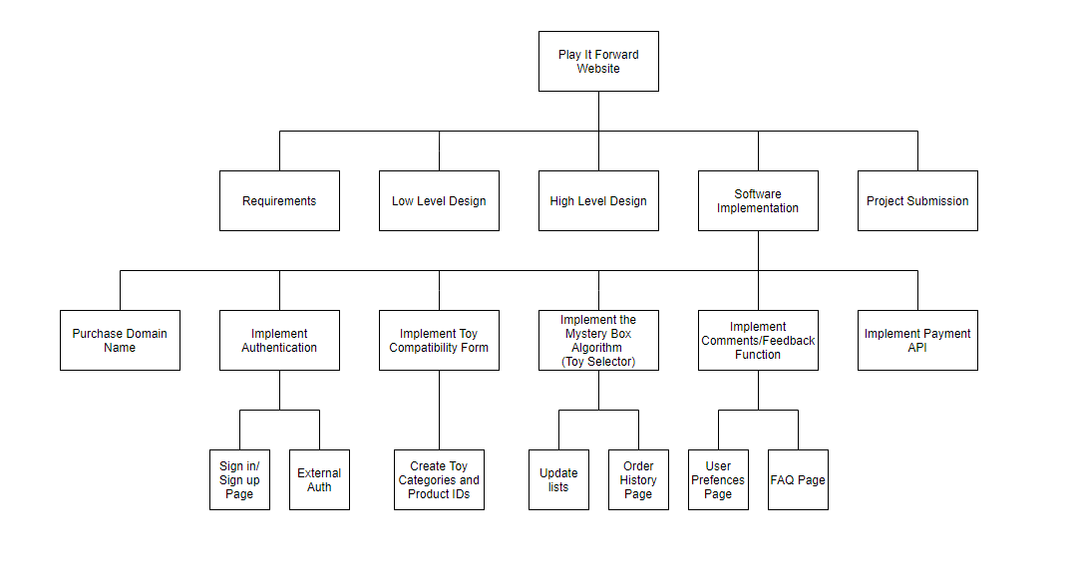

4.2 Gantt Schedule (Timeline)

